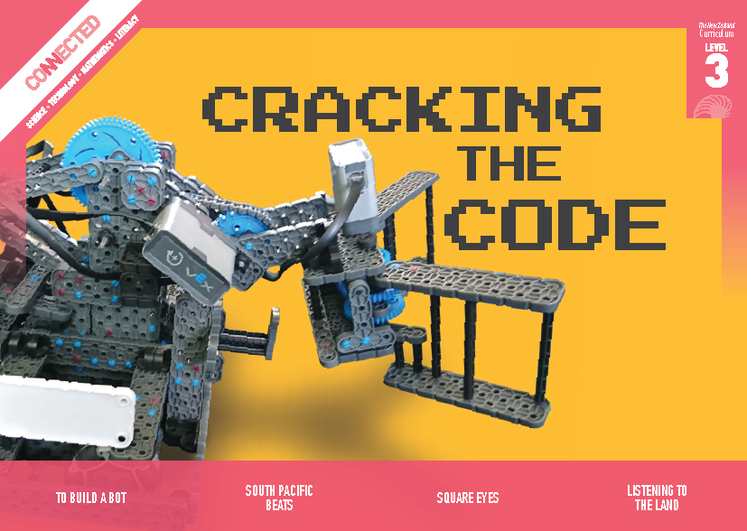
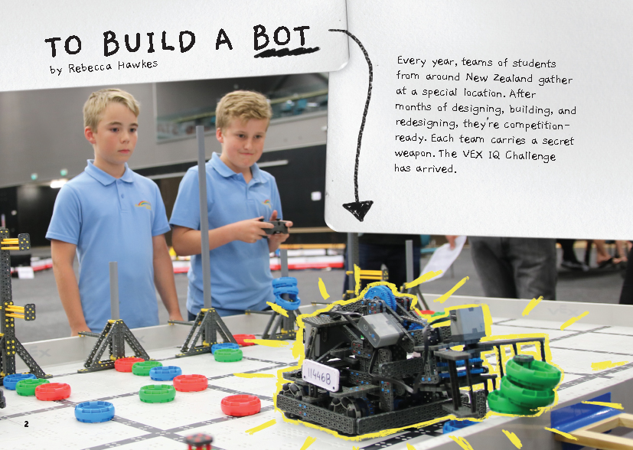
Connected
Level 3
2018

To Build a Bot
by Rebecca Hawkes

Overview
This article describes the process undertaken by three students from Feilding’s Manchester Street School as they designed and built a robot that won the New Zealand VEX IQ Challenge. The article offers an authentic way of introducing students to programming and computational thinking, as well as physics and engineering concepts related to energy, weight, and balance.
A Google Slides version of this article is available at www.connected.tki.org.nz

Curriculum contexts

TECHNOLOGY: Technological Practice: Brief development  Level 3 – Students will describe the nature of an intended outcome, explaining how it addresses the need or opportunity; describe the key attributes that enable development and evaluation of an outcome.  Computational thinking for digital technologies: Progress outcome 1  In authentic contexts and taking account of end-users, students give, follow, and debug simple algorithms in computerised and non-computerised contexts. They use these algorithms to create simple programs involving outputs and sequencing (putting instructions one after the other) in age-appropriate programming environments. | Key technology ideas  - Technological outcomes are fit for purpose.  - Prototypes are used to trial and test the design functions.  - Explicit instructions are required for the best performance of the technological outcome.
SCIENCE: Physical World: Physical inquiry and physics concepts  Level 3 – Students will explore, describe, and represent patterns and trends for everyday examples of physical phenomena, such as movement, forces, electricity and magnetism, light, sound, waves, and heat. For example, identify and describe the effect of forces (contact and non-contact) on the motion of objects; identify and describe everyday examples of sources of energy, forms of energy, and energy transformations.  Science capabilities  This article provides opportunities to focus on the following science capabilities:  - Gather and interpret data  - Critique evidence  - Engage with science. | Key science ideas  - Forces make objects move or change their movement.  - A push or pull more easily causes movement on a surface when wheels, balls, or rollers are used.  - Gears can be used to change the direction of motion.

ENGLISH: Reading  Level 3 – Ideas: Students will show a developing understanding of ideas within, across, and beyond texts. | Indicators:  - uses their personal experience and world and literacy knowledge confidently to make meaning from texts  - makes meaning of increasingly complex texts by identifying the main and subsidiary ideas  - starts to make connections by thinking about underlying ideas in and between texts  - makes and supports inferences from texts with increasing independence.
MATHEMATICS and STATISTICS: Geometry and Measurement: Position and orientation  Level 3 – Students will use a co-ordinate system or the language of direction and distance to specify locations and describe paths. | Key mathematics ideas  - Step-by-step instruction (algorithm development) using positional and directional instructions needs to be explicit.

The New Zealand Curriculum

Technology

Meeting the literacy challenges

The main literacy demands of this text lie in the significant amount of scientific and engineering vocabulary and the inclusion of digital technology concepts, some of which are quite abstract.  The photographs and diagrams offer considerable support, both explaining the basic concepts and demonstrating how the design developed. Students will need to take time to interpret these visual representations and to connect them to the information in the text.  The structure of the text is slightly different from other Connected texts, but it does follow a clear process that demonstrates how the students identified problems and found solutions. The fact that they were entering a competition gives their task a sense of purpose and authenticity and helps to underscore the relevance of the scientific and technological concepts they were working with. | The following strategies will support students to understand, respond to, and think critically about the information and ideas in the text. It may be appropriate to use all or only one or two of these strategies, depending on your students’ literacy knowledge and skills. You are encouraged to reword the suggested questions that will best suit your learners’ strengths and needs.  You may wish to use shared or guided reading, or a mixture of both, depending on the reading expertise of your students and the background knowledge they bring to the text.  After reading the text, support students to explore the activities outlined in the following pages.

INSTRUCTIONAL STRATEGIES

Finding the main ideas  Have the students read the title and introductory text and SCAN the article to predict what it will be about. Clarify that this text is all about building a robot for entry into a national competition.  PROMPT the students to speculate on what a robot is. Ask them to preview the photos and illustrations and then ask:  The title is “To Build a Bot”. What do you think a bot is?  What clues can you find in the illustrations? What do you see in the photograph on page 10?  You say that a bot is a robot. So what is a robot? Could a broom be a robot? Should robots look human?  PROMPT the students to make connections to their prior knowledge about the scientific and technological concepts involved in building a robot (for example, weight, balance, and energy).  Have you ever used construction toys like Lego or Meccano to build a robot?  What TV programmes or movies have you seen that feature robots or robotics?  What do you know about the ways that robots are used?  What might you need to think about to create a working robot?  Help the students to CLARIFY their understanding of the Vex IQ Challenge by moving them into groups of three and having each student explain one of the one-minute challenges (described on page 4) to the other two, using the diagram to support their explanations. The other two can ask questions or correct the person doing the explaining. If there is any confusion, have them check their explanations by viewing the video advertising the 2017–18 competition. | Tell the students that they have now understood the first step in the technological design process: defining the problem or challenge.  What are some of the other steps the boys and their teacher will need to work through?  Can we create a diagram to show this?  Create a flow diagram with the students to summarise the main ideas in the article. They could complete their diagrams in small groups, using an app like Popplet. Initially, the diagram might look like the one below – as they read, the students can annotate it with the details of what Kellan, Kaea, and Hunter did to get to their solution.  After the reading, have the students share their diagrams and DISCUSS what they learnt.  What problems did they encounter? What were their solutions? Have you included these in your flow chart? Add them in if you haven’t.  What was the key to the boys’ success? How could this sort of approach help us in other parts of our lives?

Meeting the literacy challenges

Dealing with unfamiliar vocabulary  Focus on the diagram on page 5. PROMPT the students to notice that this diagram introduces a lot of the words they need to understand for the rest of the article. However, some of the terms in the explanatory text may not be familiar (for example, “electrical energy”). Have the students read the labels and identify the science and technology terms and phrases. Point out that they need to know these terms to be able to operate as scientists and technologists. Have the students research these words to create definitions with examples of their use. Then give each student a copy of the diagram on page 5 and two sets of cards, one with the names of the labelled parts and one with the explanatory text. They could then:  - match the names to the explanations and the diagram  - use the completed diagram to take turns explaining the parts to each other  - take away the explanatory text and explain the parts to each other just using the names  - explain the parts to each other with no written text at all. | As the students read, have them identify other words that they will need to know in order to understand robotics. PROMPT them to notice that some of these words are defined in the text, some in the glossary, and some in the diagrams and photographs. These words, along with examples, could be incorporated in a wall display. Encourage the students to use these words as they engage in further activities and MODEL using them yourself.

TEACHER RESOURCES

Want to know more about instructional strategies? Go to:  - http://literacyonline.tki.org.nz/Literacy-Online/Planning-for-my-students-needs/Effective-literacy-practice-years-5-8  - “Engaging Learners with Texts” (Chapter 5) from Effective Literacy Practice in Years 5 to 8 (Ministry of Education, 2006).  Want to know more about what literacy skills and knowledge your students need? Go to:  - http://nzcurriculum.tki.org.nz/Assessment/Reading-and-writing-standards  - http://www.literacyprogressions.tki.org.nz/ | We have retained the links to the National Standards while a new assessment and reporting system is being developed. For more information on assessing and reporting in the post-National Standards era, see:  - http://assessment.tki.org.nz/Assessment-and-reporting-guide

Reading standard: by the end of year 6
The Literacy Learning Progressions
Effective Literacy Practice: years 5–8

Illustrating the key ideas

TEACHER SUPPORT
Technological outcomes are fit for purpose.  Prototypes are used to trial and test the design functions. | 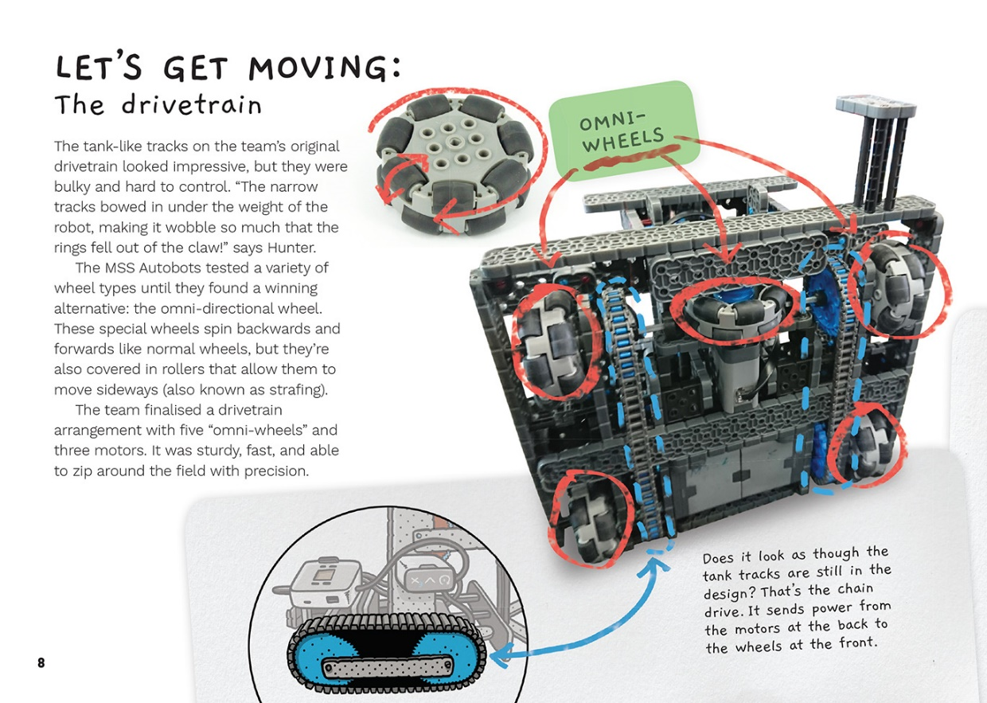  Movement on a surface is easier when wheels, balls, or rollers are used.

Learning activities – Exploring the technology,
science, and mathematics and statistics
The following activities and suggestions are designed as a guide for supporting students to explore and extend student content knowledge across the learning areas. You are encouraged to adapt these activities to support your students’ learning needs.

Activity 1 – Investigating the mathematics and physics of robotics
During the reading, the students will have identified and defined important concepts that inform the design of robotics. Now they have the opportunity to explore these concepts further.
Students could investigate the physics by:
- learning how a motor converts stored electrical energy into kinetic energy and showing this on a diagram
- investigating how we can change the shape of a structure to make it more rigid
- drawing arrows on a copy of the grid to show where the robot needed to apply force to change direction and then identifying how the robot did this.
Students could investigate the mathematics by:
- responding to the question on page 9 and breaking down Circuit Breaker’s route into instructions
- investigating how to convert their written instructions into an algorithm that could be programmed into a computer
- measuring and graphing information about angles, distance, weight, and balance as they explore the logistics of building a robot and making it move
- writing algorithms to train robots to do other simple tasks.

Activity 2 – Robots and us
Have the students work in groups to create a Frayer Model for the word “robot”. (A Frayer Model is a type of graphic organiser that includes a definition for a particular concept, characteristics, examples, and non-examples.) They can complete it using evidence from the text, their prior knowledge, and online research. Groups could focus on particular areas of interest, for example:
- researching the first robots – those that came before computers
- looking at early movies and television programmes that had robots (for example, The Jetsons and Doctor Who) and reflecting on how well these predicted today’s robots
- learning about how robots are used today.
Afterwards, the students could look at each other’s definitions to see what they can learn from each other. They could also discuss their personal responses to the increasing use of robots in our world.
What are some positives and what are some negatives of robots?
What are some robots that weren’t around when your parents were young but are becoming part of our lives?
What might the future bring?
How can we make sure that robots are a good thing and not something that could do us harm?
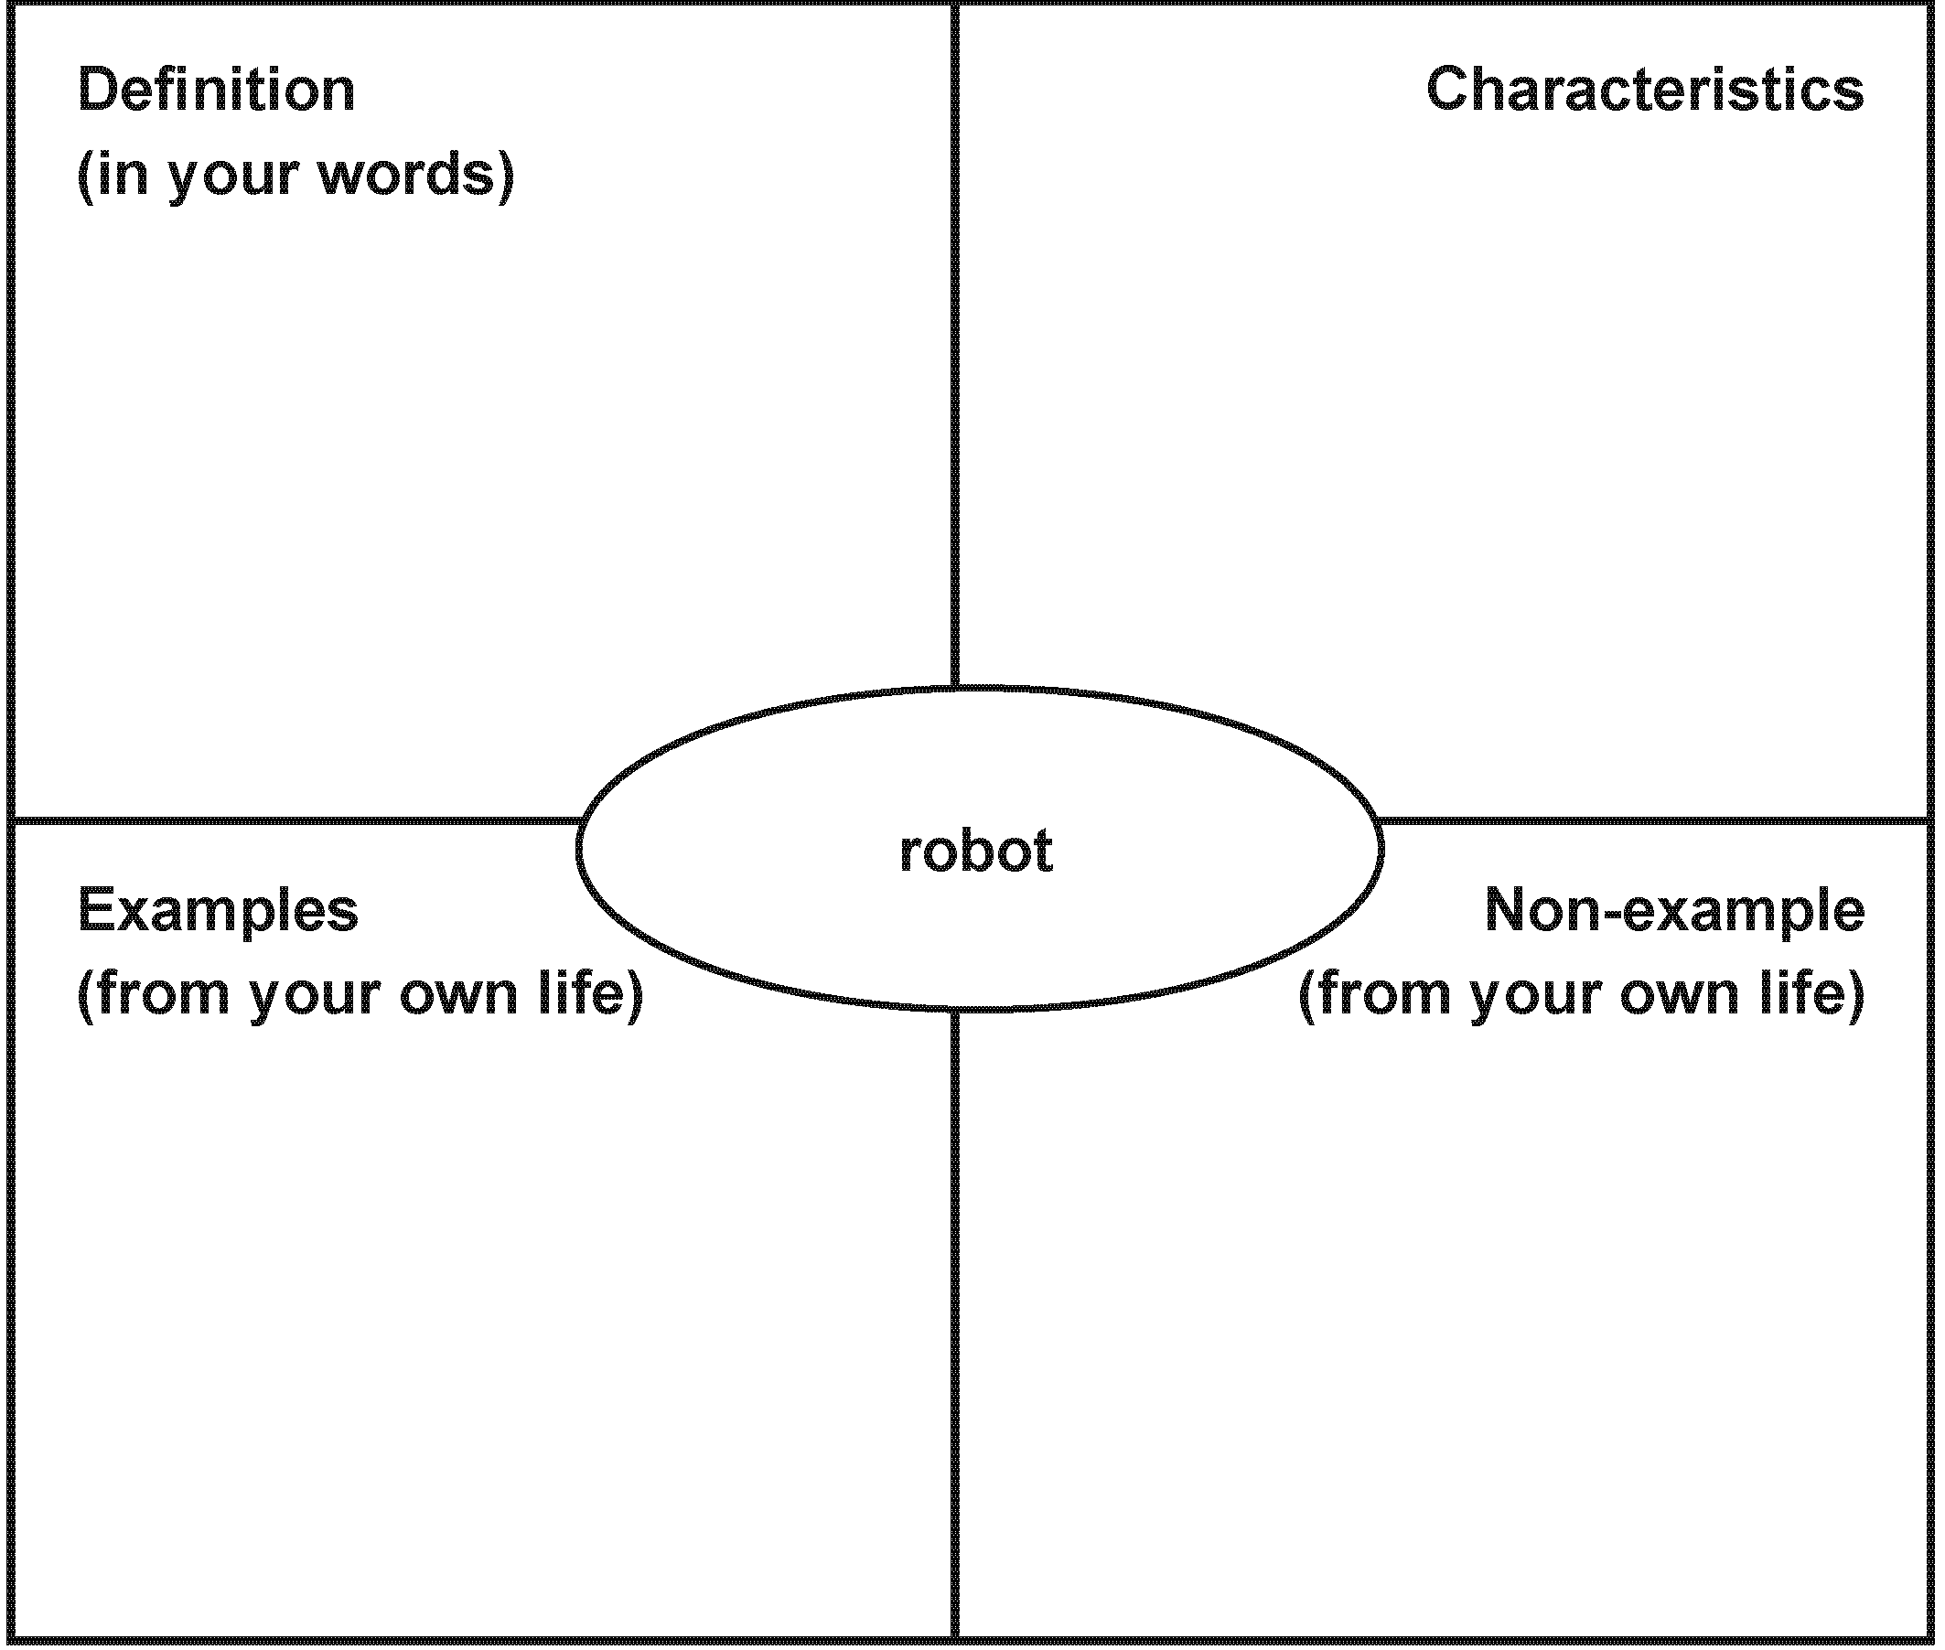

Activity 3 – Using and building our own robots
The students could use a tool such as Sphero to take part in collaborative activities that incorporate the use of robotics and technology. They could try one of the projects on the Science Buddies site to design and build their own robots. For example, the Vibrobot is powered by a vibrating motor, which means it can be made to skitter across tables, spin, or push other robots out of the way.
The students could use what they learn to design and construct a robot to meet a particular purpose around the home or school. Or they could have fun by planning their own school robotics competition. They might even want to enter the next VEX IQ Challenge!

Learning activities – Exploring the technology, science, and mathematics and statistics

RESOURCE LINKS

Connected  “Amazing Algorithms”, Connected 2018, Level 2, Step by Step  Building Science Concepts  Book 29 – Solar Energy: Sun Power on Earth  Book 42 – Marbles: Exploring Motion and Forces  Book 51 – Standing Up: Skeletons and Frameworks  School Journal  “Robot Challenge”, School Journal Level 3, October 2013  “As Easy as One, Two, Three!”, School Journal Level 2, June 2018  Science Learning Hub  Robots for horticulture: www.sciencelearn.org.nz/resources/2066-robots-for-horticulture  Mechatronics: www.sciencelearn.org.nz/resources/1607-mechatronics  Sensing robots: www.sciencelearn.org.nz/resources/1603-sensing-robots  Hi-tech drones copy nature’s design: www.sciencelearn.org.nz/resources/2352-hi-tech-drones-copy-nature-s-design  Robotic milking:  www.sciencelearn.org.nz/resources/2089-robotic-milking  www.sciencelearn.org.nz/resources/2096-investigating-robotic-milking  www.sciencelearn.org.nz/resources/2097-training-cows-to-milk-themselves  Unit plan – robotic milking: www.sciencelearn.org.nz/resources/2099-design-a-robotic-milking-system-unit-plan  Other sources  Stuff: www.stuff.co.nz/manawatu-standard/news/99690909/feilding-youngsters-eager-to-take-on-the-robotics-world-in-united-states  VEX IQ: www.vexrobotics.com/vexiq  VEX IQ Challenge: www.vexrobotics.com/vexiq/competition/vex-iq-challenge-overview | VEX IQ Challenge Ringmaster – 2017-2018 VEX IQ Challenge Game: www.youtube.com/watch?v=L7suUUs7fsU  REC Foundation – robotics curriculum: www.roboticseducation.org/educational-resources/robotics-curriculum/  A cool design at the VEX IQ 2017 Asia Pacific Championships: www.youtube.com/watch?v=osGuonvUwdc  Digital Technologies Hub (Australia) – Robotics: www.digitaltechnologieshub.edu.au/teachers/topics/robotics  Digital Technologies Hub (Australia) – Visual programming: www.digitaltechnologieshub.edu.au/teachers/topics/visual-programming  Digital Technologies Hub (Australia) – Algorithms: www.digitaltechnologieshub.edu.au/teachers/topics/algorithms  National Library of New Zealand – Any questions (Robots): https://anyquestions.govt.nz/many_answers/robots  Science Buddies – Design your own vibrobots: www.sciencebuddies.org/science-fair-projects/project-ideas/Robotics_p030/robotics/vibrobots?from=Blog#background  Science Buddies – Build fun robots with students: www.sciencebuddies.org/blog/build-fun-robots-with-students  YouTube robot wars – Grand final battle recaps: www.youtube.com/watch?v=OLfNLwxH6uc  Potential and kinetic energy for kids: www.youtube.com/watch?v=IqV5L66EP2E  How to Train Your Robot: www.nationalgeographic.org/activity/how-train-your-robot/  Web Design Schools Guide: 10 things we couldn’t do without robots: www.webdesignschoolsguide.com/library/10-things-we-couldnt-do-without-robots.html  Robotics facts: http://idahoptv.org/sciencetrek/topics/robots/facts.cfm  Sphero: www.sphero.com/education  Types of gears: www.youtube.com/watch?v=ihGFUAAwj7g

